EXPERIMENT – 7
Name: B Mohith
Roll No: 2520030028
Section: 8
Title
Observation of Memory Addresses and Process Memory Mapping in Linux
Aim
To observe the memory addresses of different variables and functions in a process and examine the process memory layout using /proc/PID/maps.
Theory
A process uses different memory regions during execution.
- Code/Text: Contains the program instructions and functions.
- Global Memory: Stores global variables.
- Static Memory: Stores static variables.
- Heap: Used for dynamically allocated memory using malloc().
- Stack: Stores local variables and function-related data.
- /proc/PID/maps: Displays the memory regions mapped into a running process.
Algorithm
- Declare a global variable.
- Declare a static variable inside main().
- Declare a local variable on the stack.
- Allocate memory dynamically using malloc().
- Display the addresses of the code, global, static, heap, and stack regions.
- Display the process ID.
- Keep the process running temporarily using sleep().
- Open another terminal.
- Use /proc/PID/maps with the process ID to observe the memory mappings.
- Release the dynamically allocated memory.
Program Code
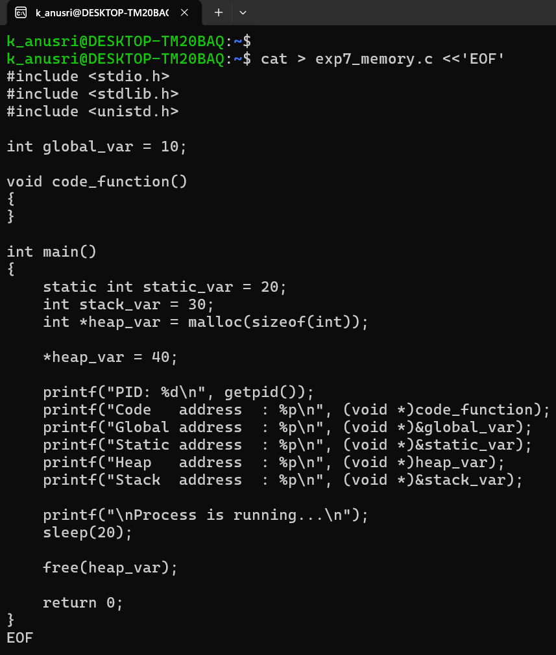

Execution and Screenshots
Screenshot 1 – Compilation and Program Execution
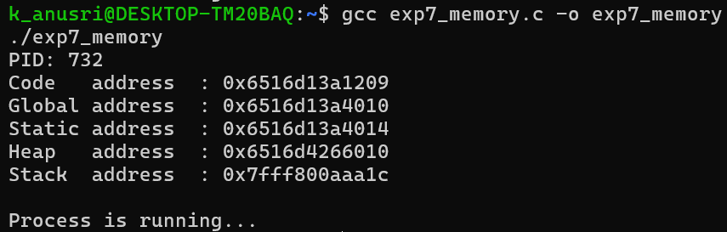

Screenshot 2 – Process Memory Mapping
IN TERMINAL 2
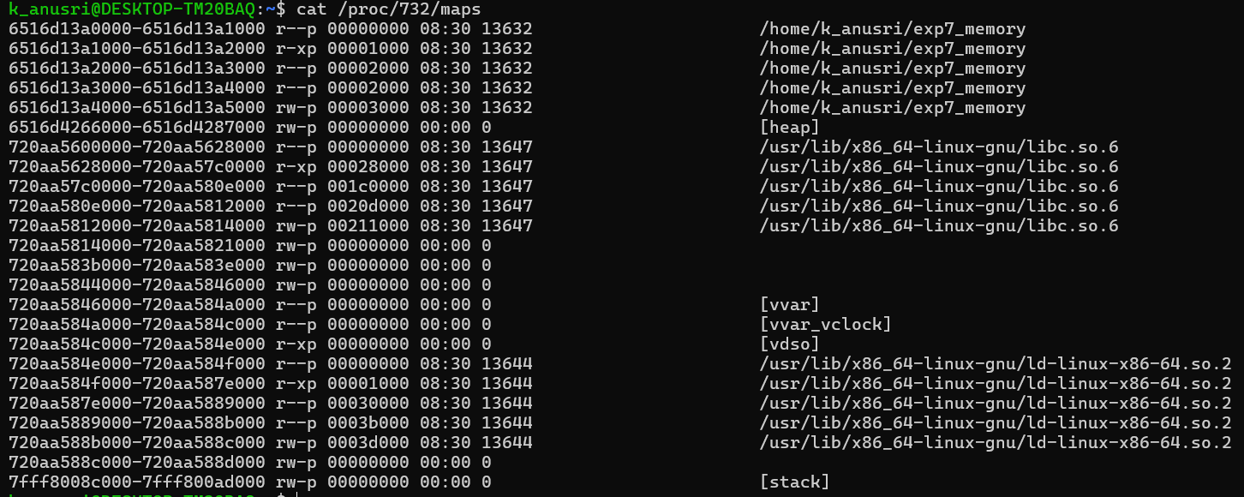
Result
The memory addresses of the code, global, static, heap, and stack regions were successfully observed. The process memory mappings were successfully examined using /proc/PID/maps.

